6. ReactJS-HOL

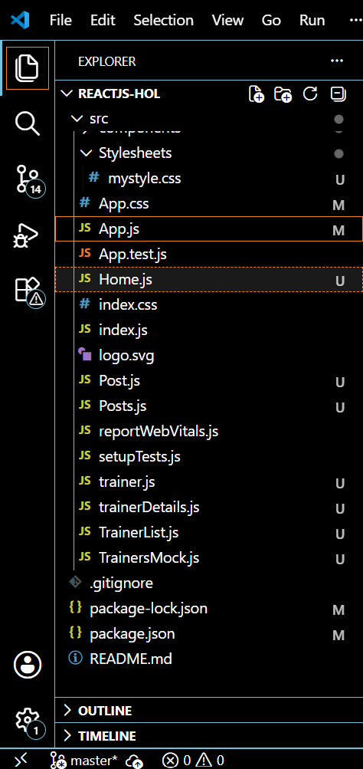

trainer.js
class Trainer {
constructor(trainerId, name, phone, email, technology, skills) {
this.trainerId = trainerId;
this.name = name;
this.phone = phone;
this.email = email;
this.technology = technology;
this.skills = skills;
}
}
export default Trainer;
TrainersMock.js
import Trainer from './trainer';
const trainers = [
new Trainer(1, "John Doe", "1234567890", "john@example.com", "React", ["JavaScript", "React", "Redux"]),
new Trainer(2, "Jane Smith", "9876543210", "jane@example.com", "Angular", ["TypeScript", "Angular", "RxJS"]),
new Trainer(3, "Alice Johnson", "5556667777", "alice@example.com", "Vue", ["Vue", "Vuex", "JS"])
];
export default trainers;
TrainerList.js
import React from 'react';
import { Link } from 'react-router-dom';
const TrainerList = ({ trainers }) => {
return (
<div>
<h2>Trainers List</h2>
<ul>
{trainers.map(trainer => (
<li key={trainer.trainerId}>
<Link to={`/trainer/${trainer.trainerId}`}>{trainer.name}</Link>
</li>
))}
</ul>
</div>
);
};
export default TrainerList;
Home.js
import React from 'react';
const Home = () => (
<div>
<h1>Welcome to the TrainersApp</h1>
<p>This app helps you browse Cognizant trainers and their expertise.</p>
</div>
);
export default Home;
trainerDetails.js
import React from 'react';
import { useParams } from 'react-router-dom';
import trainers from './TrainersMock';
const TrainerDetail = () => {
const { id } = useParams();
const trainer = trainers.find(t => t.trainerId === parseInt(id));
if (!trainer) return <p>Trainer not found!</p>;
return (
<div>
<h2>{trainer.name}</h2>
<p><strong>Email:</strong> {trainer.email}</p>
<p><strong>Phone:</strong> {trainer.phone}</p>
<p><strong>Technology:</strong> {trainer.technology}</p>
<p><strong>Skills:</strong> {trainer.skills.join(', ')}</p>
</div>
);
};
export default TrainerDetail;
App.js
import React from 'react';
import { BrowserRouter as Router, Routes, Route, Link } from 'react-router-dom';
import Home from './Home';
import TrainerList from './TrainerList';
import TrainerDetail from './trainerDetails';
import trainers from './TrainersMock';
function App() {
return (
<Router>
<div>
<nav style={{ padding: '10px', backgroundColor: '#f0f0f0' }}>
<Link to="/" style={{ marginRight: '15px' }}>Home</Link>
<Link to="/trainers">Trainers</Link>
</nav>
<div style={{ padding: '20px' }}>
<Routes>
<Route path="/" element={<Home />} />
<Route path="/trainers" element={<TrainerList trainers={trainers} />} />
<Route path="/trainer/:id" element={<TrainerDetail />} />
</Routes>
</div>
</div>
</Router>
);
}
export default App;

OUTPUT:
